CHAPTER 01

INTRODUCTION TO ROBOTICS__________________________

1.1 Automation
- Automation is the creation and application of technologies to produce and deliver goods and services with minimal human intervention.
- Automation is a broad term that can cover many areas of technology where human input is minimized.
- Automation is a technology that is related with the use of mechanical, electronic and computer based systems in the operation and control of production.
- Types of Automation:
- Fixed automation
- Programmable automation
- Flexible automation
A. Fixed automation, also known as “hard automation,” refers to an automated production facility in which the sequence of processing operations is fixed by the equipment configuration.
B. Programmable automation
Some of the features that characterize programmable automation are:
- High investment in general-purpose equipment;
- Low production rates relative to fixed automation;
- Flexibility to deal with changes in product configuration;
- Most suitable for batch production.
C. Flexible or Soft Automation
- This automation system provides the automatic control equipment that offers a great flexibility for making changes in the product design. These changes can be performed quickly through the commands given in the form of codes by the human operators.
- This automation allows the manufacturers to produce multiple products with different ranges as a combined combination process rather than separate.
- Flexible automation is used for mid volume production size. It possesses some of the features of both fixed automation and programmable automation.
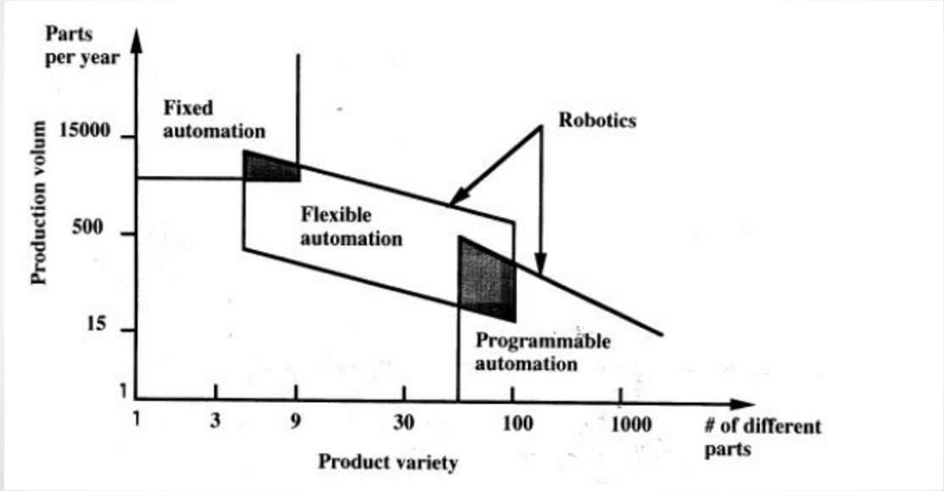
Fig: 1.1-Graph showing automation

1.2 What is robot?
- The term "robot" was first used in 1920 by the Czech writer Karel Capek.
- The word “Robot" comes from the word “Robota”, meaning, in Czech”, forced labour.
- Robot - Mechanical device that performs human tasks, either automatically or by remote control.
- Robotics - Study and application of robot technology.

1.3 Why use a robot?
- To save labour and reduce cost.
- Human is bad for the product for example semiconductor handling.
- Product is bad for the human for example radioactive product.
- Quality - While the main reason for using a robot is to save labor the biggest impact a robot has can be on quality.

CHAPTER 02

HISTORY OF ROBOTICS_________________________________
- 3500 B.C.E
- The Greek myths of Hephaestus and Pygmalion incorporate the idea of intelligent mechanisms.
- 1400 B.C.E. The Babylonians develop the water clock, considered one of the first robotic devices.
- 400 B.C.E. Chinese engineer King-Shu Tse designs a mechanical bird and horse.
- 350 B.C.E. Greek mathematician Archytas of Tarentum constructs a mechanical wooden bird whose movements are controlled by a jet of steam or compressed air.
- 725 Chinese engineer Liang Lingzan and Buddhist monk Yi Xing build a water-driven device with the world's first clockwork escapement mechanism – the first true mechanical clock.
- 1525 German scholar Hans Bullmann designs and builds humanoid androids who play musical instruments.
- 1700 Mechanized puppets known as “Karakuri Ningyo” appear in Japan, typically designed to perform a single task such as serving tea.

Fig:2.1-Kikakuri Ningyo
- 1737 French inventor Jacques Vaucanson creates several robotic beings, including a human-sized android flutist and an automatic duck that simulates quacking, drinking, eating, paddling in water, digesting and excreting.
- 1760 German inventor Friedrich von Knauss creates an android able to hold a pen and write a piece of up to 107 words.
- 1890 Nikola Tesla creates the first remote-controlled vehicles.
- 1943 Colossus, the world's first large-scale programmable electronic digital computer, is built in Britain by a team of mathematicians, electrical engineers and intelligence agents to crack Nazi codes.
- 1950 Alan Turing proposes a test to determine whether or not a machine has gained the power to think for itself. It becomes known as the "Turing Test".
- 1921 Czech author Karel Capek coins the word “robot” to describe mechanical people in his play "R.U.R" (Rossum's Universal Robots).
- 1942 American author Isaac Asimov popularizes the term "robotics" and sets out his “three laws of robotics”.
- 1951 American engineer Raymond Goertz designs the Electro Mechanical Manipulator, the first remotely-controlled articulated arm, for the Atomic Energy Commission.
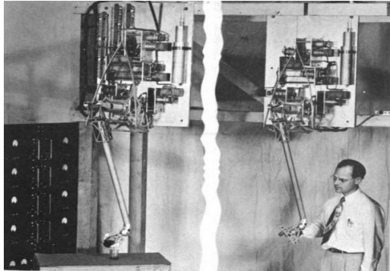
Fig:2.2-Electro Mechanical Manipulator

- 1962 The first Unimate robot is installed in a General Motors plant in Trenton, New Jersey. The assembly line spot welding robot is controlled step-by-step by commands stored on a magnetic drum.
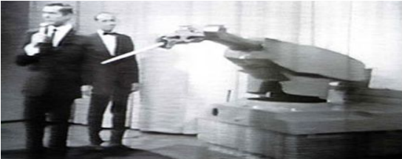
Fig:2.3-First Unimate Robot
- 1963 The first computer-controlled robotic arm is designed at Rancho Los Amigos Hospital in Downey, California as a tool for the handicapped
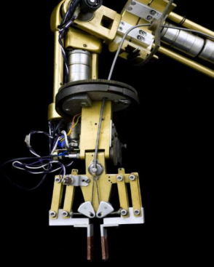
Fig:2.4-First Computer Controlled Robotic Arm

- 1968 Marvin Minsky develops a computer-controlled, hydraulic-powered, wall-mounted tentacle arm.
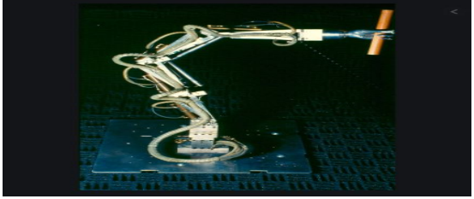
Fig:2.5-Wall Mounted Tentacle Arm
- KUKA is a German manufacturer of industrial robots and solutions for factory automation. In 1973, KUKA created its own industrial robot FAMULUS.
- 1969 The Japanese company Kawasaki develops the Kawasaki-Unimate 2000, the first industrial robot ever produced in Japan, with technology licensed from Unimation.
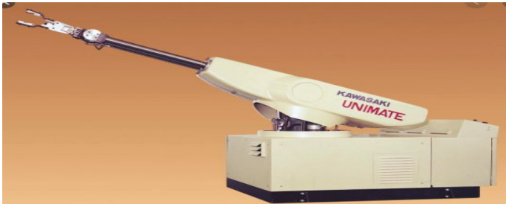
Fig:2.6-First industrial Robot
- 1978 Unimation develops the PUMA (Programmable Universal Machine for Assembly), based on Victor Scheinman’s design.
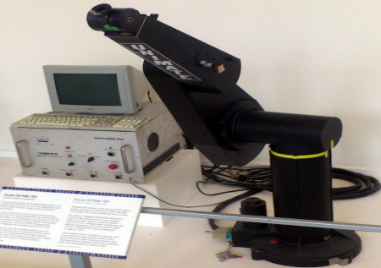
Fig:2.7-PUMA
- 1979 Austrian researcher Hans Moravec creates the Stanford Cart, an autonomous vehicle that can navigate across a room.
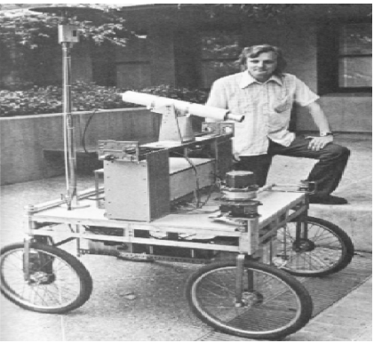
Fig:2.8-Stanford Cart
- The SCARA acronym stands for Selective Compliance Assembly Robot Arm or Selective Compliance Articulated Robot Arm was developed in 1981.
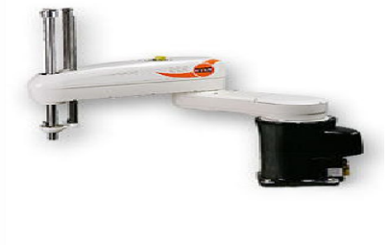
Fig:2.9-SCARA
- 1985 The PUMA 560 robotic surgical arm is used in the first documented use of a robot-assisted surgical procedure.
- 1989 The Mobile Robots Group at MIT creates a walking robot named Genghis.
- 1990 iRobot Corporation was founded by Rodney Brooks, Colin Angle and Helen Greiner and produced domestic and military robots.
- 1999 Sony releases the Aibo electronic dog robot, which reacts to sounds and has some preprogrammed behaviour.
- 1996 MIT researchers Michael S. Triantafyllou and David Barrett develop a robo-tuna. Honda creates the P-2 (Prototype 2), a humanoid robot that can walk, climb stairs and carry loads.
- 2000 Honda releases ASIMO, the next generation of its series of humanoid robots.
- 2001 The Space Station Remote Manipulator System (SSRMS) is successfully launched into orbit and begins operations to complete assembly of the International Space Station.
- TOPIO ("TOSY Ping Pong Playing Robot") is a bipedal humanoid robot designed to play table tennis against a human being. It has been developed since 2005 by TOSY, a robotics firm in Vietnam. It was publicly demonstrated at the Tokyo International Robot Exhibition (IREX) on November 28, 2007.
- Sophia is a social humanoid robot developed by Hong kong based company Hanson Robotics. Sophia was first turned on on February 14, 2016.
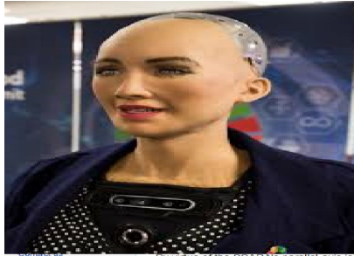
Fig:2 10-Sophia

CHAPTER 03

ROBOT CLASSIFICATIONS______________________________
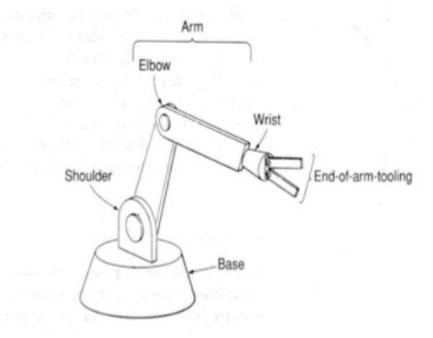  Fig:3.1-2D Model of robot arm | 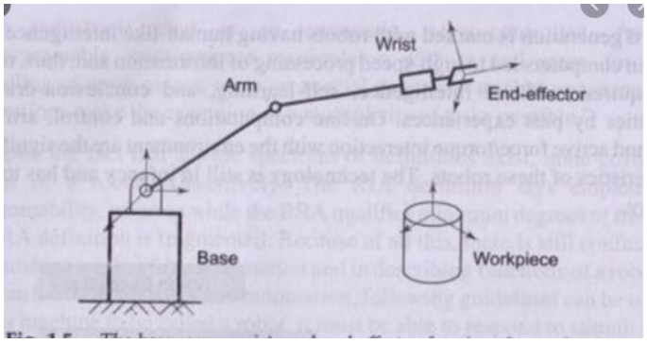  Fig:3.2-Diagram of robot arm
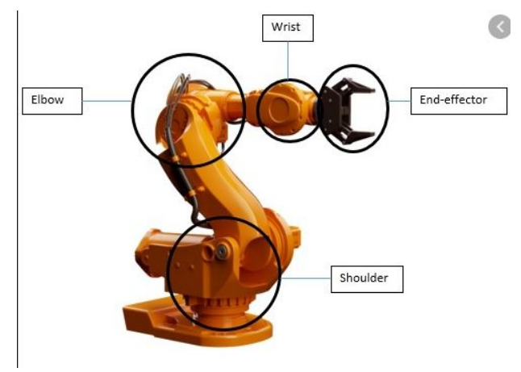  Fig:3.3-Simulation of robot arm | 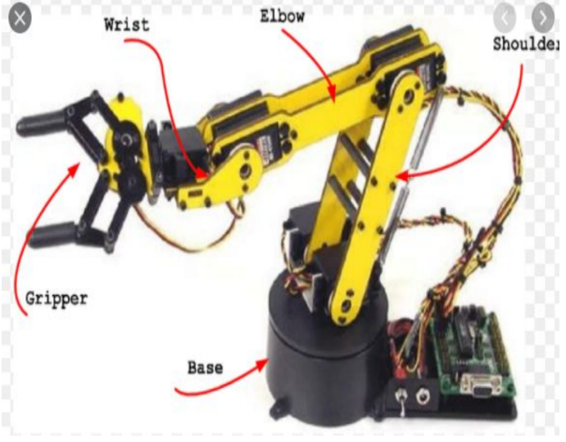  Fig:3.4-Mechanical robot arm

3.1 Degrees of freedom:
- The number of degrees of freedom is equal to the total number of independent movements that can object can perform.
- Mobility, or number of DOF, of a robot is defined as the number of independent joint variables required to specify the location of all the links of the robot in space.
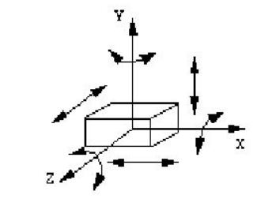
Fig:3.5-Degree of freedom
Rigid body in space has six degrees of freedom.
- Three linear motions specify the position of the body.
- Three rotational motions specify the orientation of the body.
Wrist assembly is attached to end-of-arm.
- End effector is attached to wrist assembly.
- Function of wrist assembly is to orient end effector – Body-and -arm determines global position of end effector.
- Two or three degrees of
- -Roll
- -Pitch
- -Yaw
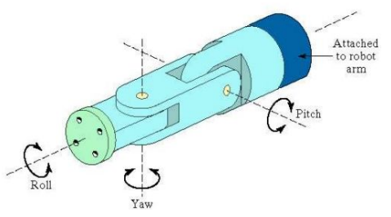
Fig:3.6-Robot arm wrist
The three degrees of freedom located in the wrist, are:
- Pitch or bend: is the up-and-down movement of the wrist.
- Yaw: is the right-and-left movement of the wrist.
- Roll or swivel: is the rotation of the hand.
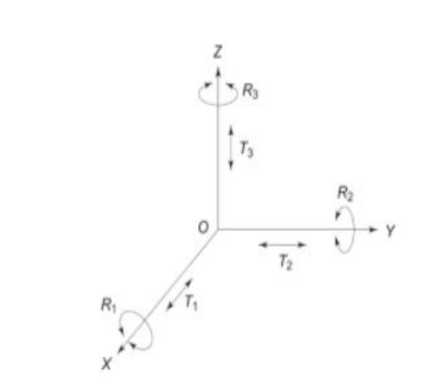  Fig:3.7-XYZ plane | 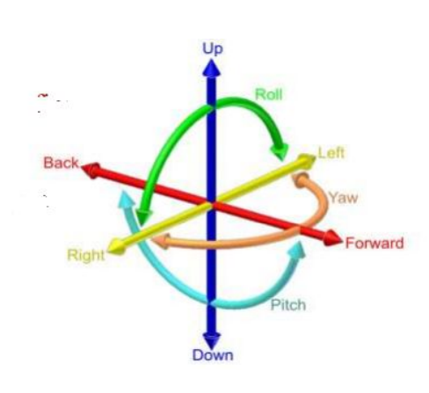  Fig:3.8-DOF

- The degrees of freedom (dof) of a rigid body is defined as the number of independent movements it has.
- Higher number dof indicates an increased flexibility in positioning a tool.
- For each degree of freedom a joint is required.
- The degrees of freedom located in the arm define the configuration.
- Three degrees of freedom located in the wrist give the end effector all the flexibility.
- A total of six degrees of freedom is needed to locate a robot’s hand at any point in its work space.
The manipulator of an industrial robot consists of a series of joints and links.
- Robot anatomy deals with the study of different joints and links and other aspects of the manipulator's physical construction.
- A robotic joint provides relative motion between two links of the robot. Each joint, or axis, provides a certain degree-of freedom (dof) of motion.
- In most of the cases, only one degree-of-freedom is associated with each joint.
- Therefore the robot's complexity can be classified according to the total number of degrees-of-freedom they possess.
1. Yaw – Rotary motion executed about 𝑧 axis. Causes movement in left and right directions. 2. Pitch – Rotary motion executed about 𝑦 axis. Causes movement in up and down directions. 3. Roll – Rotary motion executed about 𝑥 axis.
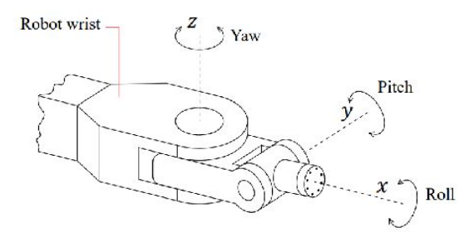
Fig:3.9-Robot wrist

3.2 work volume or work space
- The term "work volume“ refers to the space within which the robot can operate.
- Work volume is the spatial region within which the end of the robot's wrist can be manipulated.
- Robot manufacturers have adopted the policy of defining the work volume in terms of the wrist end.
- There are often areas within the working envelope which cannot be reached by the end of the Robot arm. Such areas are termed dead zones.
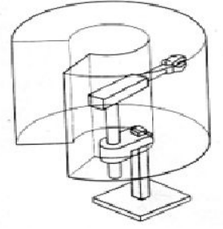
Fig: 3.10-Work space
Prismatic joint(P)
links move in linear fashion with respect to its joint. Linear joint, Orthogonal joint Revolute joint (R)
links move in rotary fashion with respect to its joint Rotational joint , twist joint and revolving joint
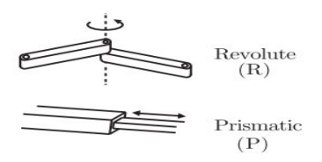
Fig: 3.11-Prismatic and Revolute Joint
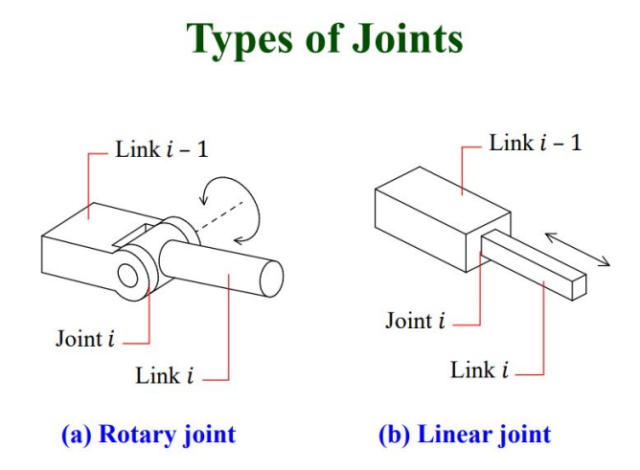
Fig: 3.12-Types of joints
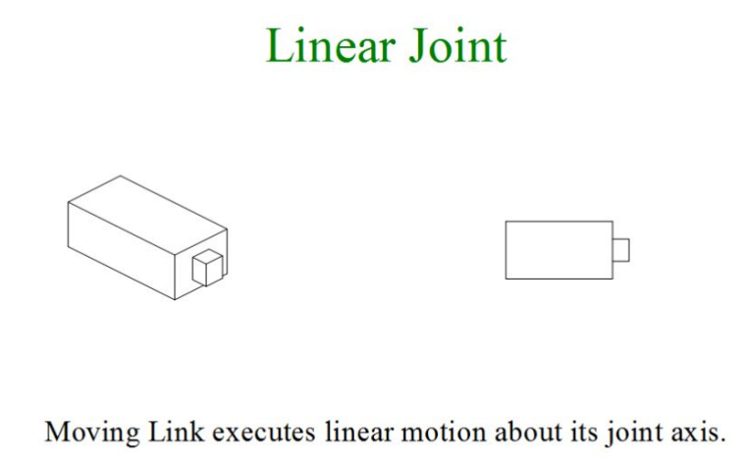
Fig: 3.13-Linear joint
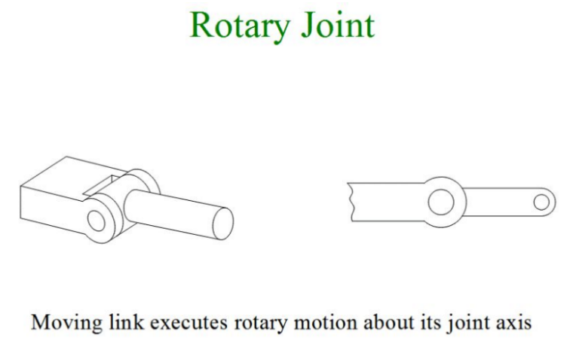
Fig: 3.14-Rotary joint
There are five types of robots which are:
- Cartesian robot
- Cylindrical
- Spherical
- Articulated/Anthropomorphic robot
- SCARA

3.3 Cartesian / Rectangular robot [P P P]
- It has 3 prismatic joints, whose axes are coincident with a Cartesian coordinate system.
- Cartesian robots are used for pick and place work, application of sealant, assembly operations, handling machine tools and arc welding. It’s a robot whose arm has three prismatic joints, whose axes are coincidental with the Cartesian coordinators.
- Most Cartesian robots come as Gantries, distinguished by a frame structure supporting the linear axes.
- Gantry robots are widely used for:
- Special machining tasks such as water jet or laser cutting where robot motion cover large surfaces.
- Palletizing
- Warehousing
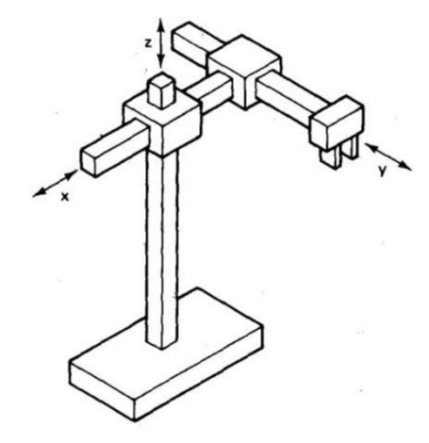  Fig:3.15-Gantry robot drawing | 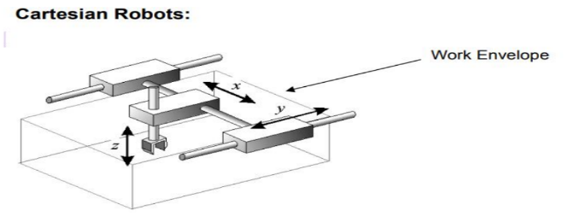  Fig:3.16-Gantry robot model

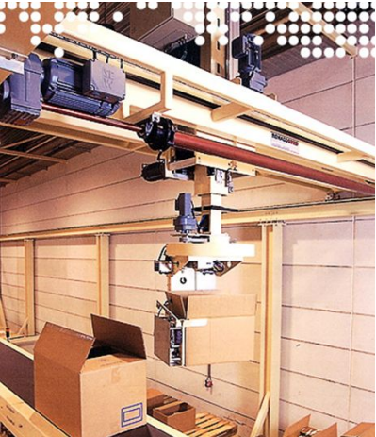
Fig: 3.17-Cartesian robot

3.4 Cylindrical robot
- The manipulator has 2 linear motions and 1 rotary motion.
- Robot’s manipulator has 1 rotational degree of freedom and 2 translational (linear) degrees of freedom.
- A cylindrical-coordinated robot generally results in a larger work envelope than cartesian-coordinated robot.
- This robot is ideally suitable for pick and place operation.
- Typical applications are assembly, conveyor pallet transfer, palletizing etc
- It can move it’s gripper within a volume described by a cylinder
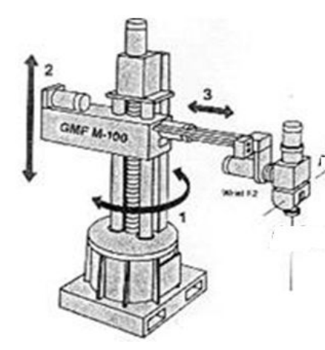  Fig: 3.18-Cylindrical robot | 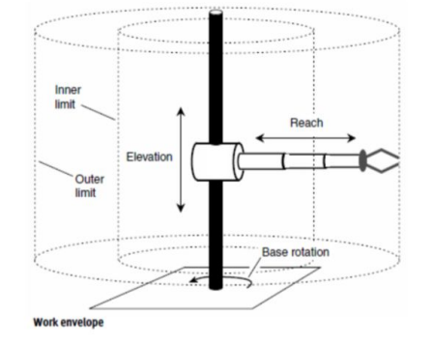  Fig: 3.19-Cylindrical robot model

3.5 Spherical / Polar robot
- The manipulator has 1 linear motion and 2 rotary motions.
- The first motion corresponds to base rotation. The second motion corresponds to an elbow rotation. The third motion corresponds to a radial/in-out/ translation.
- A spherical robot generally results in a larger work envelope than cylindrical and cartesian robot.
- This robot is ideally suitable for applications where a small amount of vertical movement is adequate such as loading & unloading a punch press
- A spherical co-ordinate robot has one linear motion and two rotary motion. I.e(2R-1P) The first co ordinate describes the angle θ of base rotation.
- The second co ordinate describes the angle Ø of elbow.
- Radial motion
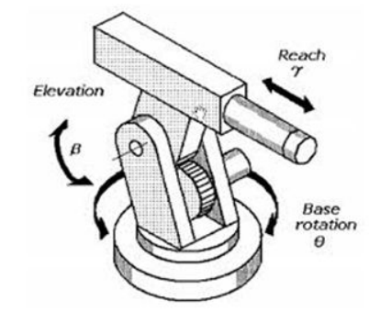  Fig: 3.20-Spherical robot model | 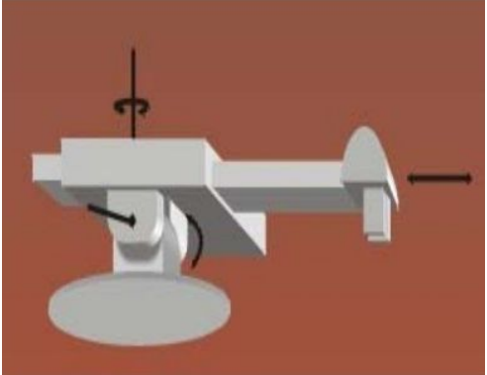  Fig: 3.21-Spherical Robot simulation

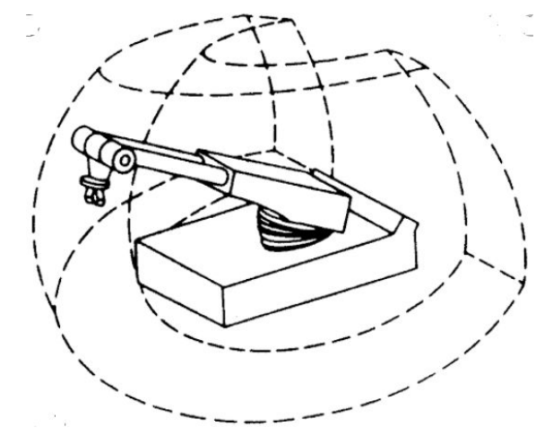
Fig: 3.22-Spherical robot work space

3.6 Vertical articulated/jointed-arm robot
- The manipulator has 3 rotary motions to reach any point in space.
- The design is similar to human arm.
- The first rotation is about the base, the second rotation is about the shoulder in a horizontal axis and the final motion is rotation about the elbow.
- It can move at high speeds and has a greater variety of angles to approach a given point and thus very useful for painting and welding applications.
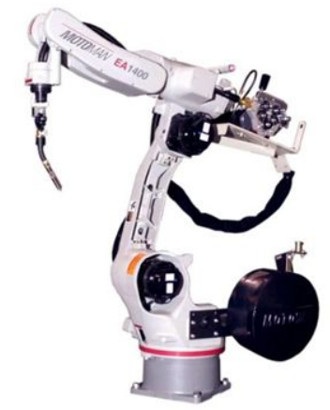  Fig: 3.23-Vertical articulated robot | 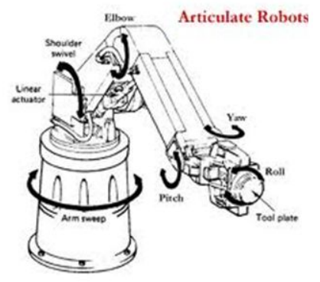  Fig: 3.24-Articulated robot model

3.7 Selective Compliance Assembly Robot Arm(SCARA)
- The manipulator has 2 rotary motions and 1 linear (vertical) motion to reach any point in space.
- This robot has 2 horizontally jointed-arm segments fixed to a rigid vertical member (base) and one vertical linear motion axis.
- It is extremely useful in assembly operations where insertions of objects into holes are required.
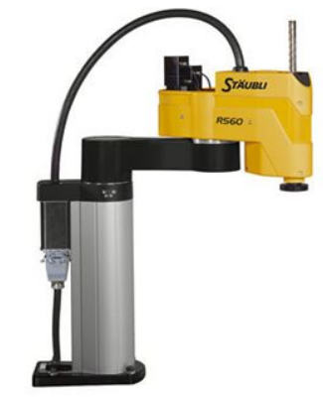  Fig: 3.25-SCARA robot | 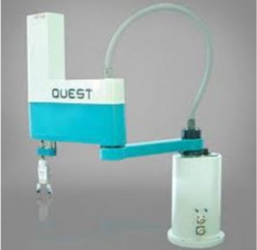  Fig:3.26- SCARA robot model

CHAPTER 04

ROBOT APPLICATIONS_________________________________

4.1 Arc Welding robots
Robot Welding is a process of joining different materials.
- Welding joins different metals or alloys with help of a number of processes in which heat is supplied r electrically.
- Arc welding utilizes an electric arc between an electrode and a metal base using either consumable or non-consumable electrodes.
- An arc welding robot uses a process which applies intense heat to metal at a joint, causing the metal to melt and intermix.
- A basic robotic arc welding system is formed by two subsystems: the welding equipment delivering the energy from the welding power source to the workpiece, and the robot providing relative positioning of the heat source and the workpiece.
- Normally six-axis industrial robots comprising a three-axis lower arm and a three-axis wrist are used, since they enable the welding torch mounted at the wrist to achieve all the positions necessary for three-dimensional welding.
- Traditionally, general purpose industrial robots are employed, carrying arc welding torches as end effectors. Many robot manufacturers have recently developed arc welding-specific robots, which are smaller and less expensive.
4.1.1 Why robot arc welding?
- Arc welding is performed by skilled workers who are assisted by a person called fitter.
- The purpose of the fitter is to organize the work and fixture the parts of the welder.
- The working condition of the welder is typically unpleasant and hazardous.
- The arc from the welding process emits ultra-violet radiations which is injurious to human vision.
- As a result welders are required to wear eye protection in the form of a welding helmet with a dark window.
- Sparks and smoke are generated during the process are a potential threat to operators.
- Because of the hazards for human workers in continuous arc welding
4.1.2 Benefits of robot arc welding
- GREATER QUALITY OF PRODUCT
- IMPROVED SAFTEY AND QUALITY-OFWORK LIFE
- HIGHER PRODUCTIVITY.
4.1.3 Features of arc welding robots
- WORK VOLUME
- DEGREES OF FREEDOM
- MOTION CONTROL SYSTEM
- PRECISION OF MOTION
- PROGRAMMING

4.2 Spot welding robots
Spot welding is a resistance welding process that uses large electrical current to join two or more sheets of metal in a single location. Spot welding technology has evolved through its extensive use in automobile manufacturing using articulated robots.
4.2.1 Benefits of robot spot welding
- IMPROVED PRODUCT QUALITY
- OPERATOR SAFETY
- BETTER CONTROL OVER PRODUCTION OPERATION
4.2.2 Features of spot-welding robots
- Robots must be relatively large. It must have sufficient payload capacity to readily manipulate the welding gun for the application.
- The work volume must be adequate for the size of the product.
- The robot must be able to position and orient the welding gun in places on the product that might be difficult to access. This might result in need for an increased number of freedoms.
- The controller memory must have enough capacity to accomplish the many positioning steps required for the spot-welding cycle

4.3 Payload, repeatability and accuracy
- Roughly speaking, the repeatability of a robot might be defined as its ability to achieve repetition of the same task.
- On the other hand, accuracy is the difference (i.e. the error) between the requested task and the obtained task (i.e. the task actually achieved by the robot.
- Robot payload is the weight a robot arm can lift.
- Maximum payload varies from robot to robot.
- Repeatability is a measure of the ability of the robot to consistently reach a specified point.
- Accuracy is a measure of the distance error associated with the desired point and achieved point.

4.4 Robot material handling applications
Today most robots are used in manufacturing operations; the applications can be divided into three categories: (1) material handling, (2) processing operations, and (3) assembly and inspection Material Handling
4.4.1 Material Handling
- Material handling (MH) makes use of the robot's simple capability to transport objects. By fitting the robot with an appropriate end of arm tool (e.g. gripper), the robot can efficiently and accurately move product from one location to another.
- Material-handling applications include material transfer and machine loading and unloading. Material-transfer applications require the robot to move materials or work parts from one location to another. Many of these tasks are relatively simple, requiring robots to pick up parts from one conveyor and place them on another.
- Machine loading and unloading operations utilize a robot to load and unload parts at a production machine. This requires the robot to be equipped with a gripper that can grasp parts. Usually the gripper must be designed specifically for the particular part geometry.

If a robot has to transfer parts or load a machine, then the following points are to be considered:
- Part Positioning and Orientation .
- Gripper design .
- Minimum distances moved .
- Robot work volume
- Robot weight capacity
- Accuracy and repeatability
- Robot configuration
- Machine Utilization Problems
4.4.2 Assembly
To assemble various components with speed and accuracy we use Assembly robot . An assembly robot moves faster and with greater precision than a human.
Robot find applications in assembly areas involving
- screwing of studs and screws in threads holes
- screwing and unscrewing of nuts
- insertions of shafts in holes
- insertion of electronics components in electric assemblies.
- assemblies of small electric motors , plugs, switches.
The inspection of robots will involve some of the sensors to calculate the worth of a manufactured part. It uses mechanical probe experiments to inspect the finished parts
A robot arm with a vision camera can also be used for non-destructive testing and 3D measurements. It can objectively identify and pinpoint defects or faulty parts before they are packed or ship.

CHAPTER 05

INDUSTRIAL ROBOTS___________________________________

5.1 Yaskawa
- GP7
- 6-Axis handling and general application
- Ideal for high-speed assembly and handling applications, The GP7 robot is fast, compact and efficient. Offering the highest payload, fastest speed and highest wrist allowable moment
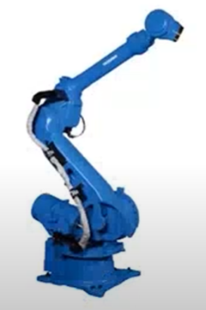  Fig: 5.1-Yaskawa robot | 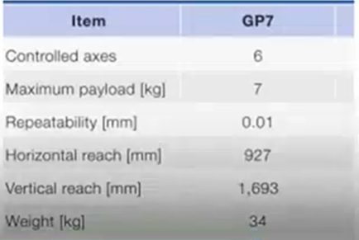  Fig: 5.2-Yaskawa robot data

5.2 FANUC
- The FANUC SR-6ia makes a great choice for assembly, pick and place, inspection and packaging applications requiring a payload capacity up to 6 Kg.
- Sitting in a small footprint, the SR-6iA offers speed and precision within a 360 degree envelope.
- Its lightweight pedestal-design and integrated services minimize the risk of interface with peripheral devices.
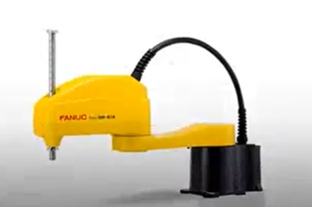  Fig: 5.3-Fanuc robot | 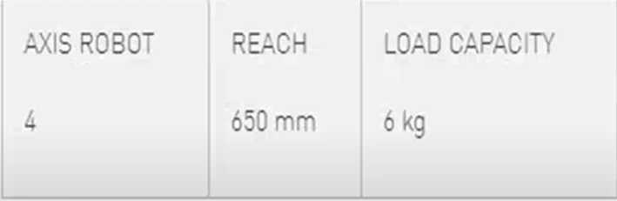  Fig: 5.4-Fanuc robot data

5.3 ABB
- The IRB 2600 is the second model in the sharp generation range with enhanced and new capabilities.
- It is a compact robot with a high payload capacity.
- The design has been optimized for targeted applications like arc welding, material handling and machine tending.
- The IRB 2600 is available in three variants, with options for floor, wall, shelf, tilted or inverted mounting configurations.
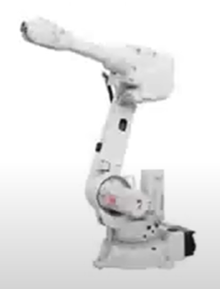  Fig: 5.5-IRB 2600 robot | 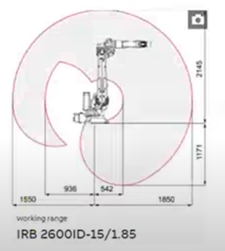  Fig: 5.6-IRB 2600 robot work space

5.4 KUKA
- KUKA expertise, packed into minimal space with the KR 3 AGLUS.
- Setting new standards for robots in the 3 kilogram class.
- This lightweight robot produces the smallest of components in manufacturing cells measuring just 600*600 mm in an agile and cost-efficient manner and with top precision.
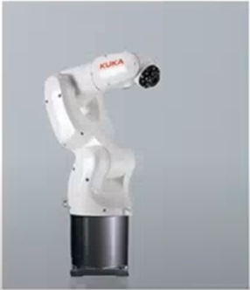
Fig: 5.7-KUKA robot

CHAPTER 06

ROBOT KINEMATICS___________________________________
- A robot manipulator is composed of a set of links connected together by joints.
- Forward Kinematics: to determine where the robot’s hand is? (If all joint variables are known)
- Inverse Kinematics: to calculate what each joint variable is? (If we desire that the hand be located at a particular point)

6.1 Forward Kinematics (angles to position)
What you are given:
- The length of each link
- The angle of each joint
What you can find:
- The position of any point (i.e. it’s (x, y, z) coordinates)

6.2 Inverse Kinematics (position to angles)
What you are given:
- The length of each link
- The position of some point on the robot
What you can find:
- The angles of each joint needed to obtain that position

6.3 Homogeneous Matrices(H) in 3D
H is a 4x4 matrix that can describe a translation, rotation, or both in one matrix.

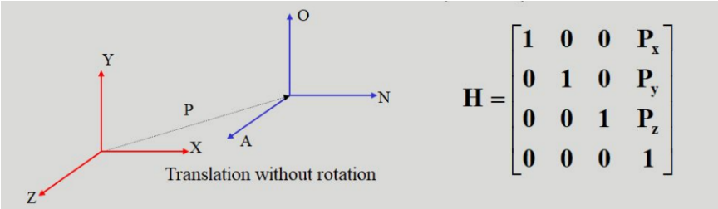
Fig: 6.1-Translation without rotation Matrix
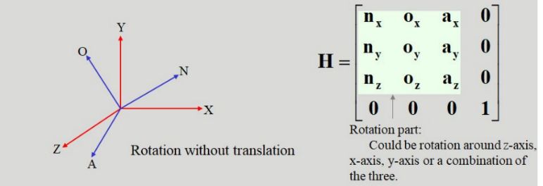
Fig: 6.2-Rotation without translation Matrix
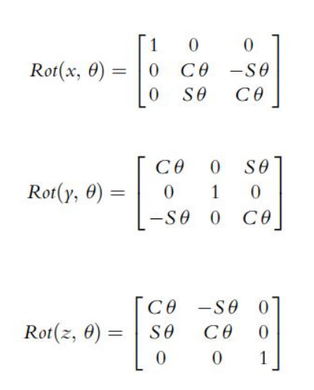
Fig:6.3-Homogeneous Matrices
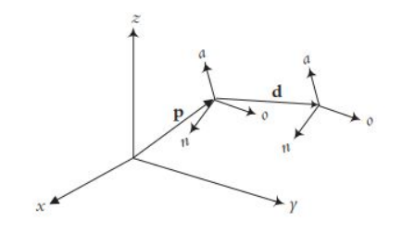
Fig: 6.4-Matrix xyz plane

6.4 Roboanalyzer
- RoboAnalyzer® is a 3D model based software that can be used to teach and learn the Robotics concepts.
- It is an evolving product developed in Mechatronics Lab, Department of Mechanical Engineering at IIT Delhi, New Delhi, India.
- Its development started under the guidance of Prof. S.K. Saha in order to support the learning/teaching of the topics covered in his book "Introduction to Robotics" published by Tata McGraw Hill, New Delhi.
- RoboAnalyzer is developed using Visual C# and OpenGL and it can currently run only on Microsoft Windows (Win XP, Vista, Windows 7, 8, 10 OS).
6.4.1 System requirements
- Processor: 1.5 GHz
- RAM: 512 MB
- Operating System: Windows XP, Windows Vista, Windows 7, 8, 8.1, 10
Some screenshots of roboanalyzer software are:
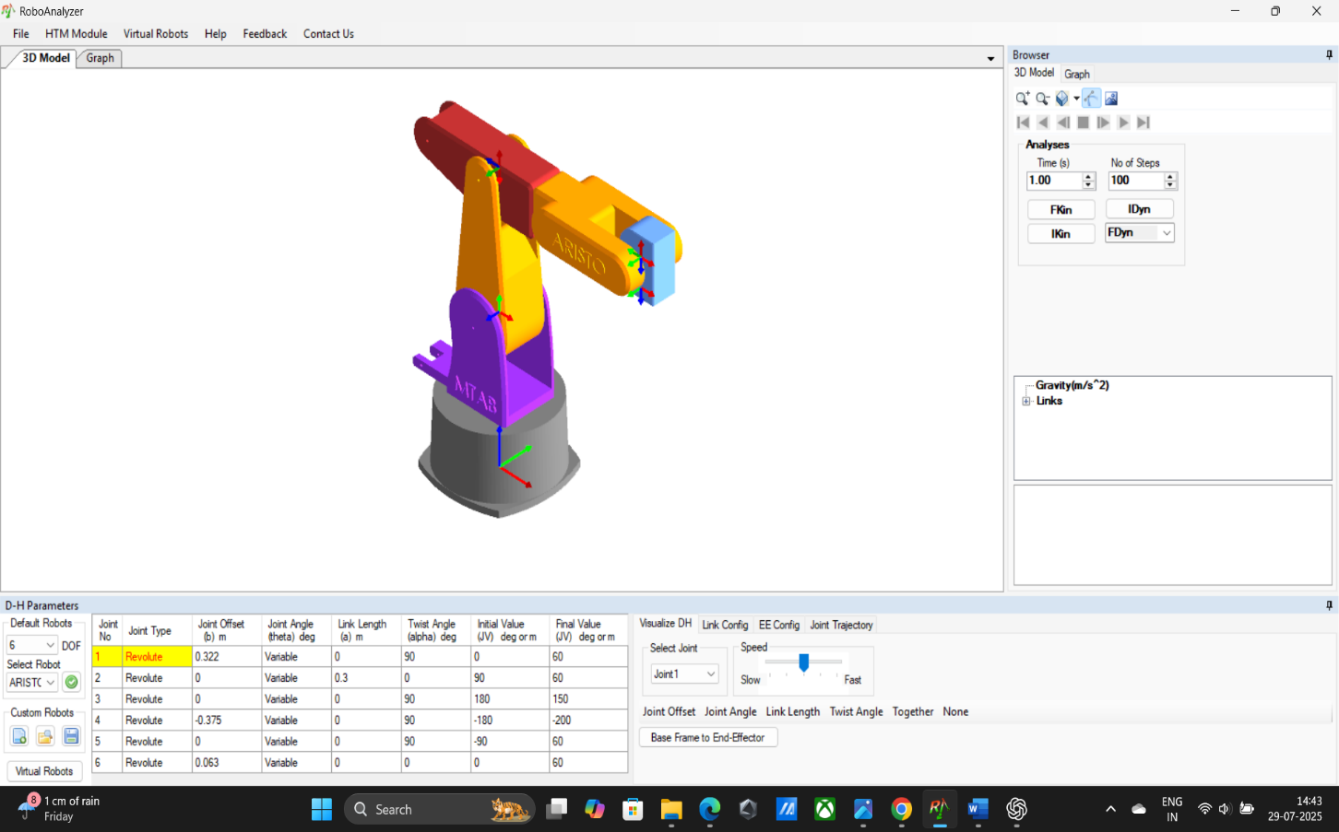
Fig: 6.5-Screenshot of Roboanalyzer software
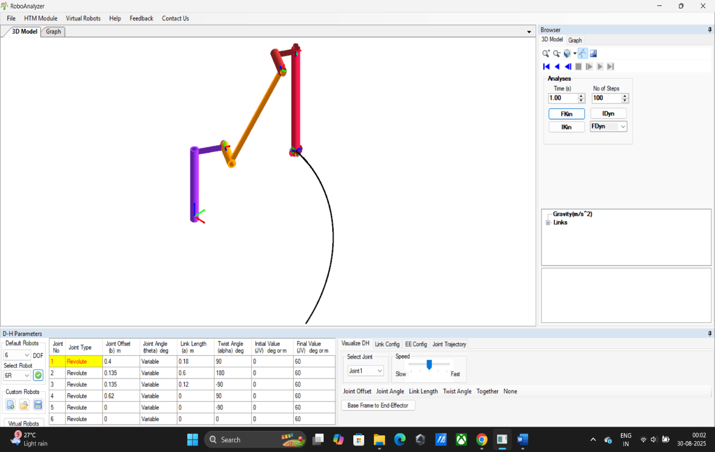
Fig: 6.6-Screenshot 2 of Roboanalyzer software

6.5 DH Parameters
- A robot is a series of links and joints, which creates a kinematic chain.
- We need to set up a coordinate frame for every joint of the robot. Once we do this, we can establish a set of transformations that will take us from one joint frame to the next adjacent.
- If we combine all these transformations from frame 0 to frame n, we can define the entire robot transformation matrix.
- All joints, without exception, are represented by a Z axis. If we have a revolute (rotary motion) joint, we rotate about Z. If we have a prismatic joint ( a linear sliding joint), we translate along Z.
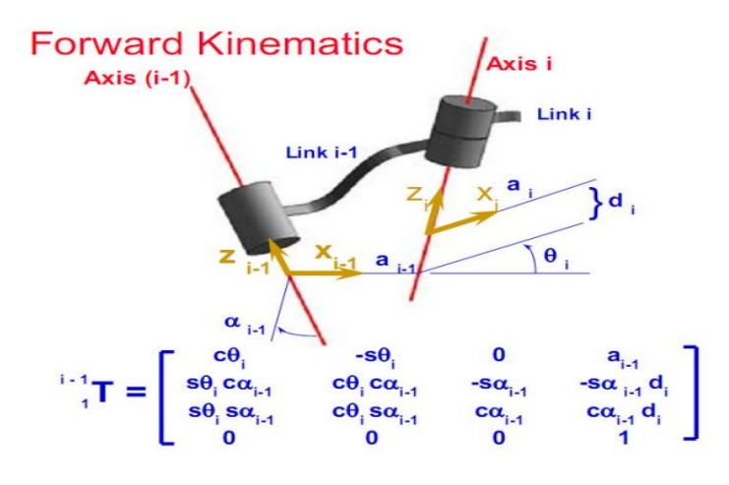
Fig: 6.7-DH parameters Matrix
- Rotate about the Z_{i-1} axis by an angle of θ_{i.} θ_{i} is called the joint angle.
- Translate along Z_{i-1} by d_{i.} d_{i} is called the link offset distance.
- Translate along X_{i} axis (newly rotated X axis from step 1 above) by a_{i}. This will bring the origins of the two coordinate frames together. a_{i} is called the link length.
- Rotate about the X_{i} axis by an angle of α_{i}. This angle is called the link twist angle, and it will align the Z axes of the two frames.
This entire process can be summarized by Changing together the 4 transformations above into a single composite transformation:
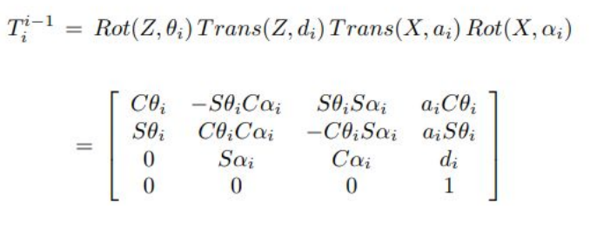
Fig: 6.8-Composite transformation
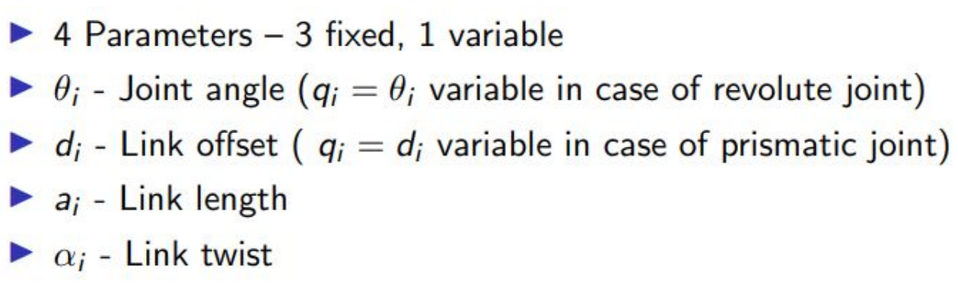
Fig: 6.9-DH parameters

REFERENCE
- Book: Introduction to Robotics, Book by Subir Kumar Saha(first edition)
- https://cyberbotics.com/doc/guide/puma
- http://www.roboanalyzer.com/tutorials.html
- https://global.yamaha-motor.com/business/robot /lineup/xyx/
- http://www.roboanalyzer.com/downloads.html (To download roboanalyzer software)
- https://www.svrrobotics.com/assets/pdf/ROC%202024%20(1).pdf
- https://www.irjet.net/archives/V6/i5/IRJET-V6I5392.pdf

